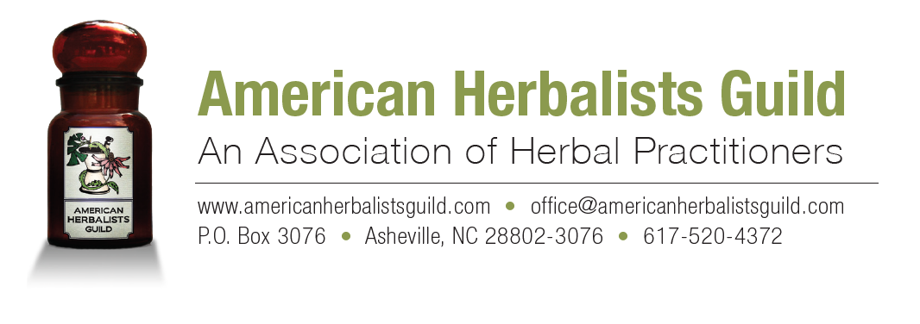
American Herbalists Guild Education Guidelines
The AHG Education Guidelines are recommendations for areas of study that are the foundation of a comprehensive herbal education. We hope they will help students plan and participate in their herbal education, whether through an in-depth herbal training program, self-study or a combination of educational experiences. They include herbal education topics that represent core competencies needed to safely and effectively practice herbal medicine; and a second section of clinical skills guidelines that outline additional areas of study for students who want to become herbal practitioners.
If you plan to apply for membership as an AHG Registered Herbalist, keep in mind that you are required to have approximately 600 to 800 hours of herbal education, along with about 400 hours of actual clinical experience. See the Criteria for Applying for Registered Herbalist Membership.
Currently there are quite a few herb schools and training programs offering comprehensive training in some or all of the topics listed here. These schools and programs are just one path to becoming a competent herbalist. Depending on where you live, your resources and the amount of time you have to devote to herbal studies, it may be that your herbal education is comprised of a variety of educational experiences. These may include formal study with various teachers and schools; extensive reading and self-study; attending webinars, workshops, conferences; and clinical mentoring or supervision. All of these options can lead to proficiency in herbalism.
To learn more about both on-site and distance herbal studies programs, start your search with our Directory of Herbal Education. Please note that AHG does not endorse, evaluate or recommend any herb school or training program. In addition to a solid education in herbalism, you will also want to apply your knowledge by working with actual clients. To support you as you build your clinical practice skills, AHG offers a Mentorship Program and Mentor Directory. The Mentorship Program is based on the AHG Handbook of Mentoring Guidelines, a valuable digital resource for student practitioners that includes suggestions for working with a mentor, setting up a practice and various forms that you can download and edit for use in your herbal practice. The handbook is free for AHG members or $10 for non-members.
The Mentor Directory is a list of AHG Registered Herbalists who are available to mentor student practitioners in person, or via phone or video conferencing. The directory includes descriptions of each mentor’s background, their availability, fees and specialty areas. Everyone listed in the directory shares a desire to support other practicing herbalists so feel free to contact them and find out more.

Herbal Education Topics
The topics listed here are those that AHG considers to be important for a well-rounded, comprehensive herbal education. Hours indicated for each topic are approximate and based on education hours as defined below.
Basic Human Sciences (200 hours) Anatomy, physiology, pathology, biochemistry, medical terminology and basic nutrition.
Materia Medica/Therapeutic Herbalism (400 hours) Botanical names, plant families, phytoconstituents, plant parts used, therapeutic actions and applications, indications, contraindications, medicinal preparations, recommended dosing, herb-drug interactions, toxicology and side effects, general review of the literature, historic uses, harvesting and sustainability status, and use with specific populations (e.g. infants, children, the elderly, pregnant or lactating women).
Pharmacy, Pharmacognosy, and Dispensing (80 hours) Basic principles of medicine making, plant chemistry and pharmacology, herbal formulation, modes of administration and delivery, maintaining a dispensary, raw material identification, laws regarding labeling and dispensing, and dispensing strategies.
Botany and Plant Identification (60 hours) Basic botany and field identification, recognition of common herbs and related toxic species.
History and Philosophy/Introduction to Research (40 hours) The philosophy of Western herbalism, the history of American herbalism and other forms of global herbalism. Research to include interpreting historical and scientific data and understanding what constitutes "evidence-based medicine."
Evidence Based and Current Botanical Medicine Research (20 hours) Familiarity with the use of research methods to access databases and sources of current research about botanical medicine.
Career Preparation/Practice Development/Ethics (20 hours) Ethics, record keeping, professional networking, scope of practice, legal issues (both national and local), confidentiality, small business management and herbal practice promotion and marketing.
AHG Clinical Skills Guidelines
These Guidelines outline the training and skills needed if you want to become an herbal practitioner and build an herbal practice. Clinical hours should be a combination of experience obtained through supervised clinical practice in a formal clinic setting, training program or mentorship (around 300 hours) and independent practice (around 100 hours). A minimum of 400 hours of clinical practice is required before applying for Registered Herbalist membership in the Guild; see the Criteria for Applying for Registered Herbalist Membership for more details.
Clinical Practice and Practitioner Skills Development (400 hours)
Intake skills, physical and differential assessment, constitutional analysis, basic laboratory test interpretation, dosing strategies, record keeping, counseling techniques for general wellness, diet, nutrition and emotional well-being, diversity awareness, professionalism, use of informed consent and full disclosure.
Definition of An Education Hour
An education hour is defined as one hour (60 minutes) of study or training gained through one of the methods listed below. To apply for AHG Registered Herbalist membership, all education hours must be documented with the name of your instructor, the title and content of the training, workshop or apprenticeship, focus of any study hours and the title and author of books read.
• Herb classes, programs or workshops (in person or distance learning)
• Formal mentorship with a clinical herbalist (in person or distance learning)
• Herbal apprenticeship
• Webinars and audio recordings about herbal practice topics
• Self-study or homework including reading or research required as part of an herb class
• Self-directed research on herb related topics

For more information about the American Herbalists Guild, visit our website at
www.americanherbalistsguild.com or contact us at office@americanherbalistsguild.com.

Revised 12/2019

