American Herbalists Guild
28th Annual Symposium
October 5-9, 2017
Silverton, Oregon

___________________________________
has completed

The Action Based Herbalism in Practice Track for Clinical Herbalists

Including at least
4 specialized 1.5 hour workshops
and a 7 hour, full day training intensive.

  - [program/Project Name]

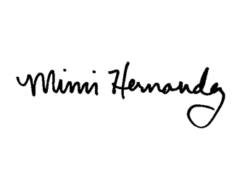
Including at least
4 specialized 1.5 hour workshops
and a 4 hour, half day training intensive.

_________________________________________________________
Executive Director, Mimi Hernandez

