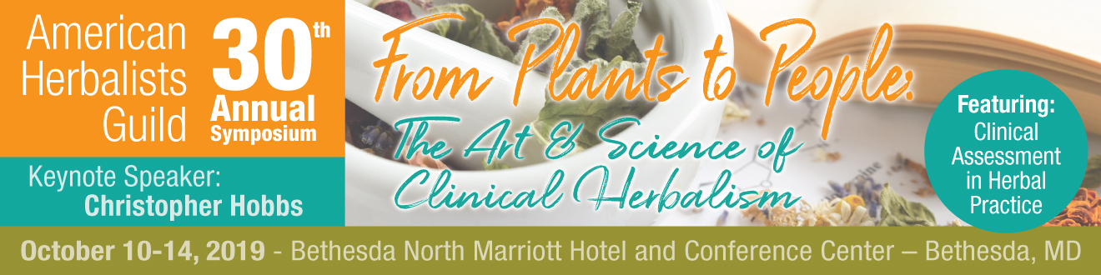

30th Annual AHG Symposium
WORK TRADE APPLICATION

Thank you for your interest in serving on our work trade team! The work trade team is essential to the smooth flow of our annual symposium. The work trade team will be responsible for assisting AHG staff, symposium presenters, exhibitors, sponsors, and attendees. Positions include classroom support, registration table assistance, event and activity set up, and AHG table support.

Work Trade Responsibilities
- Complete and submit the Work Trade Application
- Sign the Work Trade Service Agreement to confirm acceptance of your position
- Help promote the event in advance utilizing flyers, social media, etc.
- Attend a mandatory orientation meeting
- Contribute approximately 10-12 hours of assigned work at symposium

Work Trade Benefits
- Receive 50% off the symposium early bird registration price* (Your cost: $135)
*this price excludes lodging, travel, meals and intensives
- Upon your successful completion of the Work Trade Program, the gift of a one-year membership to the American Herbalists Guild

Please complete the following form and submit by July 24, 2019:
(Accepted work trade volunteers will be notified by August 16, 2019)

Name: ______________________________________________________________________________________
E-Mail: ______________________________________________Phone: _________________________________
Mailing Address: _____________________________________________________________________________
City: ________________________________________ State: ____________Zip: __________________________
AHG Membership Status: _____________________________________________________________________
What is your preferred gender pronoun? (ex. she, he, they, ze)*________________________________
*This question is voluntary and only asked to ensure we use the correct pronouns when referring to you

Why would you like to attend the Symposium as a Work Trade Volunteer? _____________________________________________________________________________________________
__________________________________________________________________________________________________________________________________________________________________________________________
_____________________________________________________________________________________________
________________________________________________________________________________________________________________________________________________________________________________________________________________

Do you have volunteer experience with AHG or similar organizations or events? ____________________________________________________________________________________________________________________________________________________________________________________________________________________________________________________________________________________________________________________________________________________________________________________

What special skills do you have that will contribute to a successful event?
____________________________________________________________________________________________________________________________________________________________________________________________________________________________________________________________________________________________________________________________________________________________________________________

Do you have experience using a Square device to process payments?
____________________________________________________________________________________________________________________________________________________________________________________________________________________________________________________________________________________________________________________________________________________________________________________

Do you have experience using social media to promote an event?
____________________________________________________________________________________________________________________________________________________________________________________________________________________________________________________________________________________________________________________________________________________________________________________

Pre- and Post-Symposium Availability
- We are in need of volunteers who can arrive by Wednesday, October 9 (by 10:00 am EST) to help set up
- We are in need of volunteers who can arrive by Thursday, October 10 (earliest shifts begin 7:00 am EST) to help with registration, the pre-symposium intensives, and Expo Hall setup
- We are need of volunteers who can stay on site Monday, October 14 until approximately 4:30 pm to aid with breaking things down and the full day post-symposium intensive

Please indicate your availability for the dates October 9-October 14, 2019.
____________________________________________________________________________________________________________________________________________________________________________________________________________________________________________________________________________________________________________________________________________________________________________________

Please indicate your volunteer assignment preference. Use the numbers 1-5 to specify you’re your desired positions from first to last.

______ Registration Desk: I am a people person and I enjoy giving customer service
______ Events and Activities: I like to work behind the scenes and help set things up
______ Classroom Support: I enjoy maintaining classroom logistics like timekeeping and AV
______ AHG Table: I have retail experience and would enjoy selling AHG products
______ Set-up/Breakdown: I enjoy physical labor and am capable of heavy lifting

Please submit this form to:
office@americanherbalistsguild.com

